Project “Castle Argh” 1.5-Page GDD
Diablo meets Monty Python

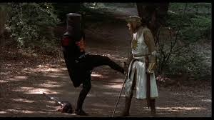
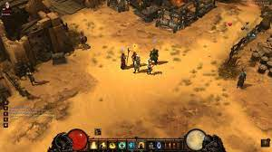

Genre: 3rd-person action RPG, single player, fixed-camera
Target Audience: 13+ (T for Teen), fans of old-school RPG & funny things
Controls: Mouse & keyboard
Thematic Setting: Mediaeval Europe / Fantasy / Knights, Swords, etc
Tech Stack: Unity 2018.3, Audacity, Asset store for 3D & UI
Platform(s): Steam
MVP Game Moment: 2 minutes of simple linear level flow with basic combat against 3 or 4 enemy types.

Game Summary: Diablo-style RPG with absurd humour of Monty Python & the Holy Grail. The game is set in an imaginary, mediaeval-lie era, with lots of muck and stinky peasants. The King/Lord doesn't much like you, his younger (slightly daft) sibling, and sends you on what he thinks is a pointless quest, to go and fetch *something* from Castle Argh. You actually end up fighting the Queen's soldiers & mutant monsters, finding ancient/magical weapons, leveling up your character, doing side-quests for crazy wizards, and finding out your real place in this smelly world.

Core Player Experience: Adventurer / being in absurd situations
Central Story Theme: Unlikely hero
Design Pillar: Putting the player in absurd / funny / ridiculous situations
Remarkability: Absurd humour

Prototype date: end of 2023

Feature Development Priorities:
- Real-time combat, with many enemies to fight
- All the required RPG abilities and stats (upgradeable)
- Level building & game progression
- Branching dialogue system
- Inventory, loot, usable items

Reference Games: Diablo, Guild Wars, Bard's Tale

